Article 1

Doctors Who Do It All: How to Start Your Own Medical Practice
Fresh out of her residency at Albany Medical Center, Dr. Dana Cohen got a job working for one of the most recognized doctors in America: Robert Atkins, of the Atkins diet.

But a few years into the job, Cohen decided that working for someone else — even a famous doctor — wasn’t for her. In 2002, the physician quit and started her own medical practice out of a New York City brownstone.

“At the time, I was so young and so naive and really had no idea what I was doing,” Cohen tells NerdWallet.

It takes years of training to become a doctor, but that might not fully prepare medical practitioners for the career path some choose: starting their own practice. It’s a daunting process, and there are a number of professionals to consult — health care attorneys, accountants, medical practice consultants.

In addition, it will take some sort of financing. NerdWallet has come up with a list of small-business loans to meet owners’ needs and goals. We gauged lender trustworthiness and user experience, among other factors, and arranged them by categories that include your revenue and how long you’ve been in business, so that you know which loans you qualify for.

Challenges of starting a private practice
Fewer doctors are starting one- and two-person practices, largely because it’s expensive to start up. It’s also difficult to deal with insurance companies and changes in health care legislation, says Franklin Walker, director of rural health initiatives at the North Carolina Medical Society Foundation. He also runs PractEssentials, the group’s consultancy.

Doctors who do decide to pave their own path face the challenges Walker cites and more. Dr. Linda Delo, an osteopathic family physician in Port St. Lucie, Florida, has struggled to bridge the cash flow gap between when she treats her patients and when the insurance companies reimburse her for the care. It’s also a challenge to get patients to pay her directly.

“If they walk out the door without paying their portion of the bill, it’s very difficult to collect it,” Delo says. Between unresolved insurance claims and patients who haven’t paid their bills, Delo says, “I have probably $100,000 if not more that’s owed to me.”

To increase her chances of getting paid on time, Delo’s staff collects patients’ insurance information and calls insurers to verify coverage before appointments. She also talks to patients about how insurance works so they understand what they’ll be expected to pay.

How to start a medical practice

When launching any small business, you need a business plan, funding and legal counsel, and you’ll need to be in compliance with federal and state regulations. Here are some things to think about as you get started.

FUND YOUR PRACTICE
Medical practitioners, like many small-business owners, often need a small-business loan or other outside capital to help cover startup costs. If you’re already saddled with medical school debt, it can be daunting to ask for more financing. But even with her student debt, Cohen got a loan backed by the U.S. Small Business Administration.

Consider your startup costs to help pinpoint how much you’ll need to borrow: real estate, construction, equipment, and attorney, accountant and consultant fees. Other expenses include computers, medical records software, office furniture and disposable supplies such as gloves, gauze and bandages. These items can add up, but you can save money if you don’t start from scratch, Walker says.

“Oftentimes, it’s less expensive to buy into a practice that’s expanding or take over for a retiring doctor,” he says.
Ultimately, Cohen’s first practice failed because she wasn’t bringing in enough patients to pay her expensive New York City rent. She opened her current practice in 2009, in a commercial space she shares with another physician to save on rent. This time, she took creative measures to cut costs.

“There were times when I had a massage therapist share the space on weekends and evenings,” she says.
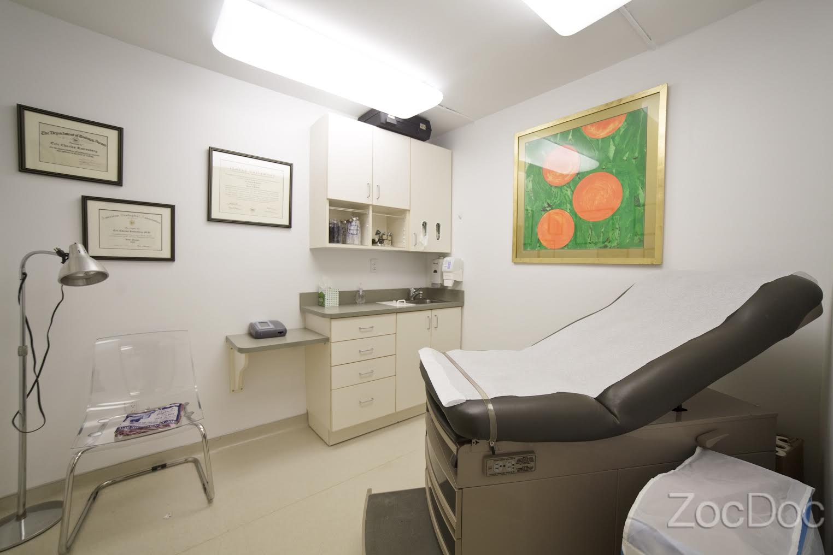
Dr. Dana Cohen’s medical office in New York. Photo via ZocDoc.

GET YOUR CREDENTIALS
You’ll need to go through a process known as “credentialing” to accept government or private health insurance from patients. The entire credentialing process can take several months. Insurers will typically ask about your medical education and residency, and they’ll want to see that you’re properly licensed and have malpractice insurance. Not all states require malpractice insurance, which varies based on your specialty and location. But having it will help protect your personal assets in case a patient sues you. Check with your state department of insurance for more information.

Your branch of medicine and your area’s demographics help inform what public health insurance programs you should consider. For example, if you’re a geriatric physician, you’ll want to sign up with Medicare. If you practice in a low-income area, you might consider participating in Medicaid. You can enroll for Medicare on the Centers for Medicare and Medicaid Services website and sign up for Medicaid with your state.

Walker recommends researching the popular private insurance providers in your state. Although Medicare and Medicaid reimburse all physicians equally for providing the same procedures, you can negotiate reimbursements with private insurance providers such as Blue Cross Blue Shield, Aetna and UnitedHealth.
“You need to decide [which insurers] to participate with and negotiate a contract with each one individually,” says Margo Williams, a senior associate at the American College of Physicians, the national group representing the internal medicine specialty.

CHOOSE A LEGAL STRUCTURE
As a small-business owner, you’ll need to choose a legal business structure, which will determine how you pay taxes and to what extent you’re personally liable for lawsuits, debt and losses. Walker says most practitioners he works with form S corporations, where they only pay taxes on their personal income from the business. This is different from a C corporation, where businesses are taxed at the entity level and on their personal income from the business.

It’s worth hiring a health care attorney to advise you on this decision and draft the legal documents — articles of incorporation, articles of organization or a partnership agreement — needed for the structure you choose.

NerdWallet has rounded up online legal services that offer money-saving DIY options and lower-cost access to attorneys.

After choosing your legal structure, you’ll need to apply for an employer identification number, or EIN, on the Internal Revenue Service website. This number identifies your business to the federal government for taxes. You’ll also need to register for state and local taxes; find information about each state’s tax registration process on the SBA website.

GET LICENSED

Before you can get your practice up and running, you need to follow relevant regulations set by the federal government and your state. Many regulations are specific to medical specialties, but here are some basic requirements that most physicians need to follow:

State licensing: You need to get licensed by the medical board in your state. The American Medical Association website has a list of links to each state’s board.

National provider identifier: All medical providers need a national provider identifier number, which you can apply for on the National Plan and Provider Enumeration System website. Medicare, Medicaid and private insurance companies use this number to keep track of health providers.

DEA registration: To prescribe medication, you’ll need a DEA number issued by the U.S. Drug Enforcement Administration. You can apply online at the DEA website.

Additional regulations: There are other specific rules depending on the type of medicine you practice and the procedures you provide. For example, if you have an in-office laboratory, you need certification by the Clinical Laboratories Improvement Amendment program through the U.S. Centers for Medicare and Medicaid Services. If you have X-ray equipment, you have to register with your state, typically through the health department.

Resources for starting a medical practice
- The Medical Group Management Association, the national organization that represents health care administrators, has a detailed checklist for starting a medical practice. The group also has affiliate chapters in each state.
- Physicians can join the American Medical Association, the industry’s national organization, to get information about legal issues, medical ethics and practice management.
- Each state has a medical group that can provide state-specific information. The Accreditation Council for Continuing Medical Education has a list of state medical societies and associations.

Article 2

HOW TO START A PRIVATE PRACTICE IN ONE DAY

THE SHORT VERSION

How to start a private practice in one day

Find a location for the private practice
Rent a space or sublease on a per session or per day basis so that you reduce your overhead. Find out when other counselors are not using the office and use those days so that it helps them make extra money and you have limited liability.
File private practice LLC Legal Paperwork
This takes about 15-20 minutes and will be around $99, depending on your state. My wife just did this through Legal Zoom and did it so fast. They even called when she filed something incorrectly. We had the LLC within a week.

PRIVATE PRACTICE LEGAL COST: $99

Get a private practice phone line
You already have a cell phone and phone systems are usually $500-$1,000 plus $25-$40 per line per month. I use Grasshopper, because it gives a custom phone line that uses the cellphone for only $12/month. The phone calls ring your cell phone and then go to your private practice voicemail. It can ring multiple phones too.

PRIVATE PRACTICE PHONE COST: $12/MONTH

Start a counseling website
When launching a website you want one that is responsive, meaning it changes based on the device being used. Also, you want to be able to adapt and change it over time when technology changes, without losing content or have to hire a web developer. Bluehost gives you that control, helps you rank higher in Google, and doesn’t cost $60 per month like some Therapy Website companies.

PRIVATE PRACTICE WEBSITE COST: $5 PER MONTH

Business Cards for Private Practice
There are tons of cheap options for business cards. I used to use them, but honestly, a business card is often one of the first impressions that someone has of you and your private practice. Having a unique or thicker business card helps you stand out. I’ve used MOO for a few years and honestly every single person says, “These are so cool, where did you get these business cards?”
PRIVATE PRACTICE BUSINESS CARD COST: $25 or so for the first round

THE LONG VERSION

Start a private practice step 1: Find a location
Don’t rent right away.
What I mean by that, is don’t get into some 3-5 year lease with month payments before you even have clients. Instead, work with an established private practice to sublease space when they don’t use it. I’m sure there a are counselors in private practice that don’t use their offices every night and weekend.

How to ask about subleasing or renting by the hour for a private practice
Here’s how the a conversation about renting a private practice space might go:
“Hi, this is Joe Sanok, I’m opening Mental Wellness Counseling in the next few weeks, may I speak with Dr. Thomas?”
“This is Dr. Thomas.”
“Hey Dr. Thomas, I’ve looked through your website and it looks like your space is in an area of town that I’m looking to rent. I’m exploring ways to initially start a private practice with lower start up by subleasing or renting by the hour. I’m wondering if there are times that you don’t use your office that you would be interested in discussing me renting?”
Often times it takes some follow up meetings and realistically you won’t be able to get this confirmed in one day, but sometimes you get lucky!

Tips for renting when starting a private practice
- Be very respectful: This is their private practice space. Understand that many private practice owners prefer to be in charge of their own space, private practice, and environment. That’s why they went into private practice!
- Get to know the counselor: Find things in common. Do some research, do they like golf, sailing, or hiking? Find ways to connect emotionally.
- 20% of income: Shoot for your bottom line cost to be less than 20% of your income. That means that if you charge $80 per session, try to pay around $16 per session. You’ll want to figure out sliding fee within this as well. If you do 10 sessions at $80 per session in a month, that is $800 income. Try to have rent be 20% of the costs for your private practice, or $160.
- Be crazy-flexible: If they only have Tuesday before 11:00 am, Thursday evenings and the weekend free, take it! It will teach you to work within a schedule with clients. Also, your clients will think you are really busy to have such limited hours.

Tip 2 for starting a private practice: File LLC LegalPaperwork
First, I’m not a lawyer or attorney, so make sure you look at your state’s rules, regulations, and expected paperwork. What is a LLC? A LLC (Limited Liability Company) is a structure for a private practice (or any company for that matter). It separates your own assets from that of the company, making it harder for someone to sue you personally, go after your personal assets (home, retirement, money) if they win a lawsuit. Also, you can then have a bank account and use the name with the full legal protection. You can also file a DBA (doing business as) but it does not have the same legal protection.
Tip 3 for starting a private practice: Best phone system
I used to be with a traditional carrier, but every time I wanted to add a line to the voicemail it was $15 per voicemail. Then, when we were moving the cost of phones was around $900 for 6 phones. That didn’t even include other month fees! Here’s an awesome video about how it works!

Best website for counseling private practices, tip 4
Launching a website is essential for any business, but with website development costs, it’s hard to know where to spend your money. Bluehost offers hosting (where the info is stored) and the ability to purchase your URL (the www.____.com thingy). Also, by installing WordPress you’ll have great control for ranking higher in Google.
Once you get hosting going (around $5/month) and get your URL, here is the first in the walk-throughs of how to install WordPress.

Create private practice business cards that help you stand out: Tip 5
Lastly, business cards are your very first impression-maker. Don’t skimp! A private practice business card should be sturdy, unique, and represent you! Get something cool, fresh, hip, and amazing, people will make the assumption that your private practice is edgy, able to handle new and complex situations, and stays up on technology. Check these things out!

Research Assessment #7
Date: November 18th, 2016
Topic: Creating a Practice
MLA Citation(s):
“How to Start a Private Practice.” Practice of the Practice, www.practiceofthepractice.com/articles/how-to-start-a-private-practice-in-one-day-for-less-than-200/.
NerdWallet. “How to Start Your Own Medical Practice - NerdWallet.” NerdWallet, 4 Nov. 2016, www.nerdwallet.com/blog/small-business/how-to-start-a-medical-practice/.
Assessment:
Doctors have a lot to think about in their life. This includes earning money and spending time with their family, conversing with patients and colleagues, and securing their business. However, the most important thing is to save the patient’s life in front of them. This is what inspired me to propose my original work of creating my future clinic for this year in ISM. In the future, I will have too much to worry about in my job itself as a cardiologist. Having a plan for my clinic will allow me to concentrate on issues that I would love to deal with, which is with treatments and procedures after my many years of schooling. From my web articles I researched, I found that there are specific steps and procedures I must follow to be successful in creating my clinic.
The first article I researched from Nerdwallet clearly lists the most important measures I must take to build a successful clinic. This includes “funding the practice”, credentials, legality, and licensing. These are vital to starting a clinic because they all are necessary to practice legally. One interesting thing that I thought that may help me is taking loans. I know that I will be accumulating a great amount of debt from my schooling to become a cardiologist; however, to fund my practice, there is not another option. From this I realized the need to take risks in a career. Risks will be available to me in the future, and it is up to me to take up the challenge or stand by to be under the supervision of another doctor my whole life. To be a cardiologist, it is very important in fact to have my own clinic to ensure a stable source of income and have a lesser stress level in the nature of the career. Moreover, I must be available for legal help from lawyers and other professionals with experience for additional guidance to make decisions pertaining to the business.
In the second document that I researched from Practice of the Practice, I discovered additional procedures that I can take to legalize and advertise my clinic, including location, legal papers, phone lines, website, and business cards. These things seem very minor; however it is actually very important to start and maintain a good number of patients in the clinic. From this article, I also learned the importance of having a good relationship with the counselor of the practice. This will ensure that I will get to use the area to the most of my abilities and at the same time, be affordable. Being a cardiologist with the additional weight of learning finances and marketing will become very hectic, but with the correct guidance and planning, I may be able to have my own clinic without the stresses to establish it.
Overall, the goal that I have for myself is to ease the stress of the future years by completing how much ever I can do now, in regards to handling financial and business aspects. Moreover, from the information I have collected, I will be interviewing professionals working in the financial and legal departments to better understand what will be required of me to create a clinic. Also, I may talk to marketing managers to learn how to gain more patients, in turn helping myself and my fellow physicians earn a living.

