Research Article #1 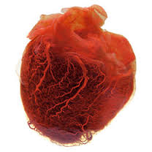In our series on work experience, we are trying to shadow various doctors in different areas of medicine to give you a good idea of what working as a doctor is like and what you might expect to see whilst on work experience.

Of course this is no substitute for actual work experience, but we think it is very useful to give a realistic idea of what to expect.

8.30AM
A typical Monday morning for me begins on the ward rounds.
My team has been on call over the weekend and we must see each new patient and work out whether they’re all on the correct treatment, whether any tweaks to their medication might be needed or whether we need to speak to other specialists to get involved.
9.30AM
One elderly patient collapsed whilst out walking and ended up on our unit. He underwent stenting (see below) of his coronary arteries yesterday but it is clear that this was not very beneficial.
Examining him, it is clear there is nothing more that can be done for him. He had a fairly severe heart attack, and a large part of his heart muscle has died.
If he were younger he may be a candidate for surgery but I do not think the surgeons will be particularly keen to get involved here.
He will, nevertheless be discussed at our afternoon multidisciplinary meeting, where cardiologists and cardiothoracic surgeons discuss patients together to decide on the most appropriate management plan. In his case I feel this is a simply a formality, but we shall see.
11.30AM
One other patient has arrived this morning with an arrhythmia. He had been feeling faint intermittently for a number of months, but this time he collapsed and had to be brought in.
Following my initial assessment it is clear that he will require a permanent pacemaker to prevent such attacks in future. This will be done in the next few days whilst he is still an inpatient.
I need to call my colleagues to see whether anyone has the space to fit him onto their list.
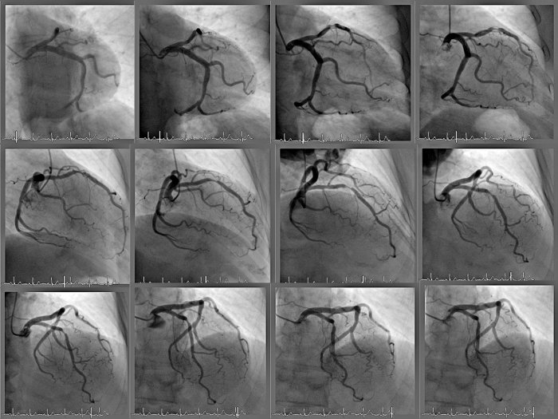
1PM
Lunch is unfortunately eaten alongside my secretary who insists I need to go through some urgent paperwork with her.
She shows me emails from patients demanding to have their clinic dates changed and their angioplasty brought forward. We are running to capacity and I need to decide what can possibly be done to keep everyone happy.
Of course this is hardly ever possible. I manage to sort out a plan that means I will have to work faster during one overbooked clinic next week, and my secretary will have a horrible afternoon re-organising everything for next week’s cardiac catheterisation list. What a great result.
2PM
The afternoon is spent in a cardiac catheterisation laboratory. I have two afternoons here a week, and I feel it is the most interesting part of my job.
I perform a variety of procedures, from angioplasty and stenting of narrowed coronary arteries, to pacemaker insertion and simple investigations.
The most difficult case of the afternoon turns out to be a simple angioplasty or stent insertion for a gentleman that turned out to have much more severe disease than previously appreciated. One of the arteries is completely blocked and after multiple attempts using some fairly sophisticated techniques we manage to get enough of a channel opened to get some flow across the artery. Only time will determine whether this will result in better function for this patient’s heart but we’ve certainly tried our best.
6PM
This long case means we must cancel our last patient as we’ve run out of time. We need to re-assign a date and time to her before she goes home. This simply adds to the pressure on our schedule for the next few weeks.
I must apologise to the patient we’ve cancelled and she is actually very understanding. Most patients are.
7PM
I must now head back to my office to catch up on emails that have been neglected.
Of the issues I must deal with the most pressing is a medical student that appears to be failing her cardiology module. The medical school would like me to see whether I can offer her any extra clinics.
Other problems are mainly concerning our pharmacy department trying to dictate which cardiac drugs it should stock without fully consulting all of the consultants.
As with most NHS problems, I’m sure cost is at the bottom of all of this, but we must at least have a consensus that ensures everyone has feels they been involved.
8PM
It’s a late finish, like most days. Cardiology is a busy speciality with increased out of hours commitments over recent years. However the job is still rewarding and fascinating and one that I would recommend to junior colleagues that show an interest.
PROS:
Instant rewards when patients treated well
Multidisciplinary approach to most problems
The interventional side involves some minor surgery and some very technical procedures
A variety of subspecialties within cardiology

CONS:
Increasing intensity of out of hours work by senior cardiologists
Reduced private incomes (as in many other specialties)
Cost and length of training, most trainees now have a higher degree
Increasing Competition

Research Article #2

What is a Cardiologist?
A cardiologist is a doctor with special training and skill in finding, treating and preventing diseases of the heart and blood vessels.
What is an F.A.C.C.?
An F.A.C.C. is a Fellow of the American College of Cardiology. Based on their outstanding credentials, achievements, and community contribution to cardiovascular medicine, physicians who are elected to fellowship can use F.A.C.C., Fellow of the American College of Cardiology, as a professional designation.
The strongest evidence of achievement for those who earn the F.A.C.C insignia comes from their peers. Letters of sponsorship from other F.A.C.C.s and medical school faculty attest to professional competence and commitment to excellence, and are necessary for election to Fellowship in the College.
When accepting election to Fellowship in ACC, each physician pledges, "cooperation and loyalty to the attainment of the ideals" of the College, the most important of which is to promote excellence in cardiovascular care.
Each year at ACC's Annual Scientific Session, newly appointed Fellows take part in the convocation ceremony honoring their new rank as F.A.C.C. and reaffirming the commitment to furthering optimal cardiovascular care. New Fellows receive their certificate of Fellowship and are officially recognized as Fellows of the College at the convocation ceremony.
How are Cardiologists Trained?
Cardiologists receive extensive education, including four years of medical school and three years of training in general internal medicine. After this, a cardiologist spends three or more years in specialized training. That’s ten or more years of training!
How Does a Cardiologist Become Certified?
In order to become certified, doctors who have completed a minimum of ten years of clinical and educational preparation must pass a rigorous two-day exam given by the American Board of Internal Medicine. This exam tests not only their knowledge and judgment, but also their ability to provide superior care.
When Would I See a Cardiologist?
If your general medical doctor feels that you might have a significant heart or related condition, he or she will often call on a cardiologist for help. Symptoms like shortness of breath, chest pains, or dizzy spells often require special testing. Sometimes heart murmurs or ECG changes need the evaluation of a cardiologist. Cardiologists help victims of heart disease return to a full and useful life and also counsel patients about the risks and prevention of heart disease. Most importantly, cardiologists are involved in the treatment of heart attacks, heart failure, and serious heart rhythm disturbances. Their skills and training are required whenever decisions are made about procedures such as cardiac catheterization, balloon angioplasty, or heart surgery.
What Does a Cardiologist Do?
Whether the cardiologist sees you in the office or in the hospital, he or she will review your medical history and perform a physical examination which may include checking your blood pressure, weight, heart, lungs, and blood vessels. Some problems may be diagnosed by your symptoms and the doctor’s findings when you are examined. You may need additional tests such as an ECG, x-ray, or blood test. Other problems will require more specialized testing. Your cardiologist may recommend lifestyle changes or medicine. Each patient’s case is unique.
Via our Patient Stories videos, you can experience real-life stories of heart patients, and how they have worked closely with their cardiologists, families and health care team to achieve the best heart health possible.
What Kinds of Tests May the Cardiologist Recommend or Perform?
Examples include:
- Echocardiogram – a soundwave picture to look at the structure and function of the heart.
- Ambulatory ECG – a recording during activity to look for abnormal heart rhythms.
- Exercise test – a study to measure your heart’s performance and limitations.
- Cardiac Catheterization – a test in which a small tube is placed in or near the heart to take pictures, look at how the heart is working, check the electrical system, or help relieve blockage.

Is My Cardiologist a Surgeon?
No, however, many cardiologists do tests such as cardiac catheterizations that require small skin punctures or incisions, and some put in pacemakers.
Do All Cardiologists Perform Cardiac Catheterizations?
No. Many cardiologists are specially trained in this technique, but others specialize in office diagnosis, the performance and interpretation of echocardiograms, ECGs, and exercise tests. Still others have special skill in cholesterol management or cardiac rehabilitation and fitness. All cardiologists know how and when these tests are needed and how to manage cardiac emergencies.
How Does the Cardiologist Work with Other Doctors in My Care?
A cardiologist usually serves as a consultant to other doctors. Your physician may recommend a cardiologist or you may choose one yourself. As your cardiac care proceeds, your cardiologist will guide your care and plan tests and treatment with the doctors and nurses who are looking after you.
Where Do Cardiologists Work?
They may work in single or group private practices. Many cardiologists with special teaching interests work in universities where their duties also include research and patient care. There are cardiologists on staff in the Veterans Administration hospitals and in the Armed Forces.
Will My Insurance Cover the Services of a Cardiologist?
Yes, in most cases. However, insurance plans vary and each case is handled individually. Your doctor and office staff will be glad to discuss your insurance plan and billing with you.
What Questions Should I Ask My Cardiologist?
There are basic questions to remember to ask, in addition to whatever questions are on your mind. For instance, if you have had a coronary angiogram, you may ask to see the pictures of your heart and have your cardiologist explain what they mean. Your heart and health are, of course, vitally important to you. Remember, your cardiologist wants you to understand your illness and be an active participant in your own care.

Research Assessment #2
Date: September 11, 2016
Subject: Cardiology
MLA citation(s):
"What Is a Cardiologist?" Global. Web. 12 Sept. 2016.
"Work Experience: A Day in the Life of a Cardiologist." Doceatdoc. Web. 11 Sept. 2016.
Assessment:
As much as I think I know about the topic of cardiology, in reality this is false. I must still dig into the necessities to become a skillful cardiologist. I had known that the profession entails a great deal of effort where the schooling period is concerned and that it is a rewarding process due to the financial matters. However, from my web research I have gathered insight pertaining to a cardiologist’s daily life, certification, and problem solving skills.
In the first article, “Work Experience: A Day in the Life of a Cardiologist” it explains the chronological order of events that occur on a cardiologist’s typical twelve-hour shift. I have realized that the normal day in the clinic is extremely busy with patients here and there to answer, schedule conflicts to address, and various types of meetings to attend. Also, it is vital that I should be aware that some patients only have a slim chance of survival; meetings are conducted to consider the likeliness of this situation. In regards to patients rescheduling, it is normal, but however, scheduling another time is the next obstacle because usually the calendars are full. I hope to be organized and be able to communicate effectively with patients about their appointments. From this article I have discovered that in this twelve-hour shift, it is busy and at the same time rewarding. I aspire to learn how to deal with the high demanding nature of the career through the ISM program soon.
Additionally, the second article, “What Is a Cardiologist?” from Global was helpful in that it explains that the Fellow of the American College of Cardiology (F.A.C.C.) is a great recognition as it creates a professional designation because there is an election. This seems like something that I may be interested in. To achieve this appreciation, it entails me to study for an ample amount of years to ultimately achieve the goal of pursuing cardiology. For me to be certified, I must also be able to pass a test. In general, cardiology requires me to remain focused and study the best I can to receive the best results. I have also learned that cardiologists are not surgeons, but I must know how to make incisions and such procedures. I must be able to meet with other doctors in regards to my patients because I would be in charge of their health. Overall, a cardiologist’s job description explains that I must educate the patient about their disease to find a solution to their health problem.
Finally, from both articles above, I have realized a theme that I must be a problem solver to be able to adapt to the various scenarios and eventually find a working solution for the patient. One issue may be about scheduling where many people request for the same times for an appointment. I must be flexible to find another time that would be available for the patients. Another example would be in treatments where not all treatments turn out to have the anticipated results. To make everybody happy, I must learn how to remain patient and positive because “each patient’s case is unique”.
From my research, I have discovered that being a cardiologist requires an ample amount of energy to fulfil because of the long hours at work, the busy clinic with waiting patients, and the need to be organized with a calendar of the days of appointments. I am looking forward to learning more about my topic of study. By learning more about the process of becoming a cardiologist, I hope to be prepared to tackle future obstacles with ease to further solidify my passion.

